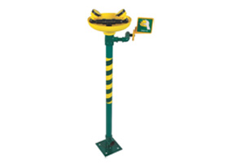

LSE 1 : EYE/ FACE WASH - PUSH
LEVER OPERATED
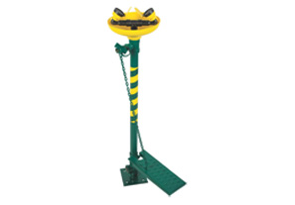

LSE 2 : EYE/ FACE WASH - FOOT
PEDAL OPERATED
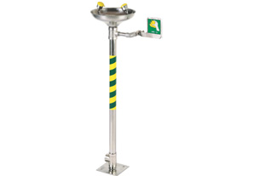

LSE1 CSS 304: EYE/FACE WASH -
PUSH LEVER OPERATED
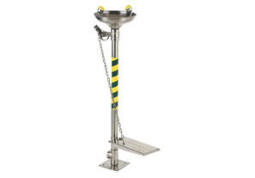

LSE2 CSS 304: EYE/FACE WASH -
FOOT PEDAL OPERATED
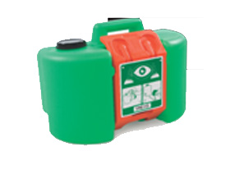

PORTABLE EYE WASH
UPEW 14
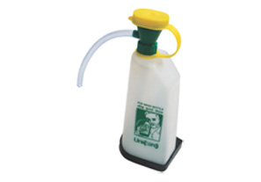

EMERGENCY EYE WASH BOTTLE -
UEWB 12 (Capacity 600ml)
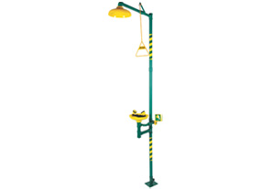

LSES 7 GI - EYE/FACE WASH AND
SHOWER OPERATE
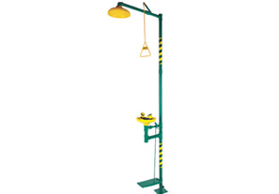

LSES 8 GI: EYE/FACE WASH AND
SHOWER OPERATE INDEPENDENTLY

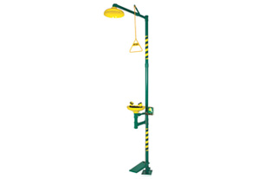

LSES 7/8 GI: EMERGENCY COMBINATION
EYE/FACE WASH PUSH LEVER & PEDAL
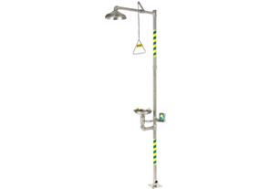

LSES 7 CSS 304

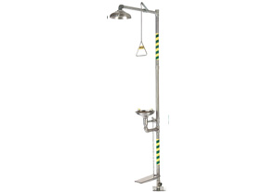

LSES 8 CSS 304

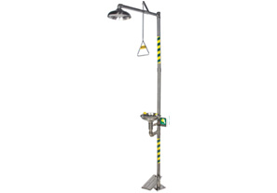

LSES 7/8 CSS 304

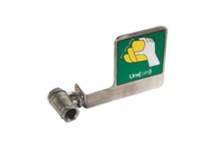

SS EYE WASH VALVE WITH
SS PUSH HANDLE
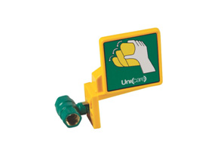

BRASS EYE WASH VALVE WITH
PUSH HANDLE
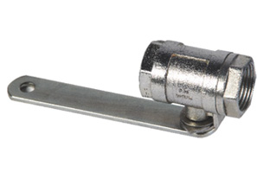

SS SHOWER VALVE WITH
SS BALL & STEM
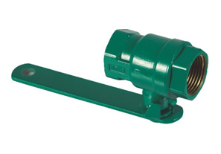

BRASS SHOWER VALVE WITH
SS BALL & STEM
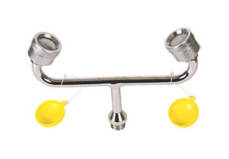

SS SLIM-LINE ATOMISER UNIT with
FLIP-FLOP DUST COVERS
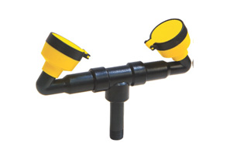

ABS ATOMISER UNIT with FLIP-
FLOP DUST COVERS
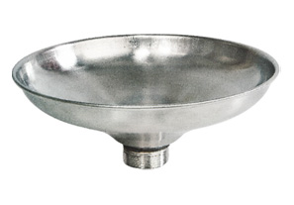

SS RECEPTOR
BOWL
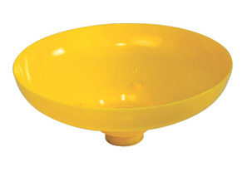

ABS RECEPTOR
BOWL
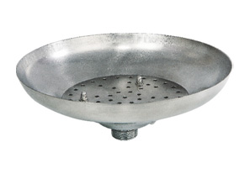

SS SHOWER DOME
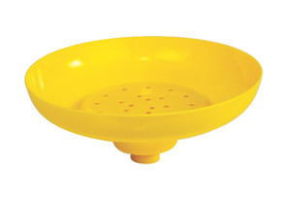

ABS SHOWER DOME
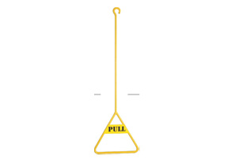

PULL ROD

